**Create a Spring Web Project using Maven**

**Step-1: created a project using spring initializr**

**Step-2: imported it with given dependencies**

**Step-3: opened in eclipse**

**Step-4: Added a simple log statement to know if project working**

**Step-5: successfully executed the project**

**Output:**

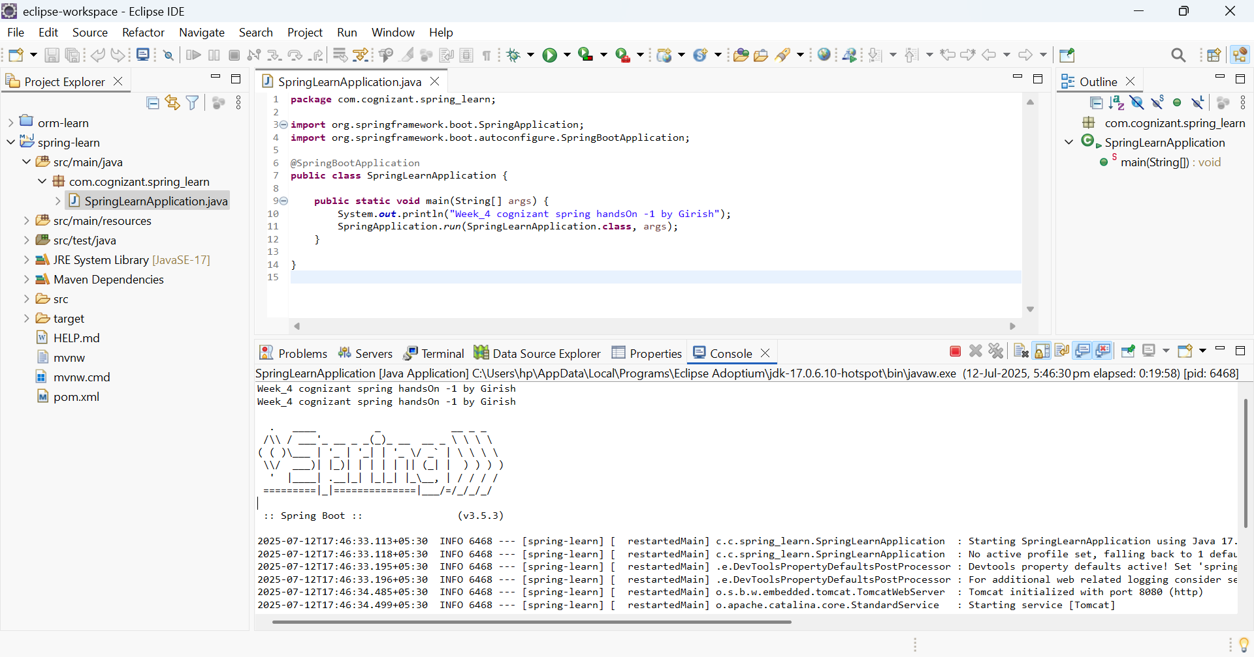

**Step-6: installed eclipse m2e for dependency heirachy**

**Help->eclipse marketplace->type maven integration-> click and install eclipse m2e maven support**